Airbnb Online Experience an analysis of the digital space

Abstract
With Covid-19 we have had a further increase in peer-to-peer exchanges, which have also taken on a digital nature in terms of the content of the exchange. For this very reason, the following research aims to verify, whether there is a relationship between the physical location of digital experiences and the residence of the users of that experience, through the help of a correspondence analysis. From the perspective of a Mixed Methods design, following the correspondence analysis, a content analysis and digital ethnography of the reviews of 16 experiences on Airbnb's portal was arranged, in order to go and understand some of the elements of similarity and dissimilarity among the spatial aggregation groups, identifying what elements direct the choice of a digital experience.

Amalia Caputo (Social science Department, Naples, Italy, +393388705594)
Vincenzo Laezza (Social science Department, Naples, Italy, +393496283780)
Simone Paesano (Social science Department, Naples, Italy, +393492444793)

Keywords: Airbnb, digital methods, digital turism.

Table of content
Introduction 3
Issues of method 4
Fruitors and digital experience: a multidimensional quantitative exploration. 6
Airbnb's digital experience and perceptions of the digital space. 8
Conclusions 13
Bibliografy 15

Introduction
The tourism sector has suffered greatly from the Covid-19 restrictions, which have made physical travel between one country and another difficult, sometimes impossible. However, some tourism realities have shown greater resilience, finding creative alternatives to the impossibility of travel, such as Online Experiences (Oe). These are guided tours that take travelers into a new era of realism and interactivity with minimal technological apparatus (Zhu & Cheng, 2021); in other words, they are organized and enjoyed online and provide a smart solution to traditional tourism. They are, to all intents and purposes, virtual tourism experiences realized through visualization technologies, executed on live-streaming communication platforms so that they allow interaction between customer and host. They are usually organized and managed by tour guides or local experts and place social interaction at the heart of the entire experience. It could also be argued that Online Experiences are a complex set of both technological and human resources, which tourists willingly resort to when they are physically, economically, or temporally unable to sustain the trip (Dolnicar & Talebi, 2020).
Airbnb, according to Harvard is "the leading peer-to-peer tourism hosting platform", which introduced Online Experiences in early 2020, ushering in the season of stay-at-home travel. The aim is to allow users to continue to travel and experience new places around the world safely while staying on their couch at home. The experiences offered have a duration of 60 to 90 minutes, in which the host guides the excursion through photos, videos, and other materials. They are real video calls that take place on the Zoom communication platform, with a variable cost, which on average is around $20 per person (Norum & Polson, 2021). Since their launch, the number of available experiences has increased and the types of activities available have diversified. Currently, Airbnb classifies activities according to 17 main categories to choose from, these include 'Great for groups', 'History & Culture', 'Cooking', and others. The creation of new interactive digital experiences is an indicator of success and enthusiasm on the part of the market (Cenni & Vasquez, 2021).
The main studies concerning this new form of tourism focus on studies of online reviews and user satisfaction, which have emphasized that the latter tend to consider the experience already lived by others to be of crucial importance; in particular, among the elements most taken into consideration is the interaction with the host: good communication between host and user is the basis of a satisfactory experience (Baute-Diaz, 2019). Other factors that tourists mainly look for in a travel experience are affordability, memorability, involvement and entertainment, authenticity, contact with the local culture, hospitality, and the perceived quality of the information received (Pine & Gilmore, 1999)). Other important elements that the potential customer takes into account before deciding whether or not to have an experience are those related to the image and reputation of the chosen destination. In the field of tourism and hospitality, researchers have shown that when referring to the image of the destination, the most commonly used keywords in experience descriptions are 'impression', 'perception', 'belief', and 'idea'.
Tourists' satisfaction or, on the contrary, dissatisfaction depends to a large extent on their expectations regarding the destination and their perceived image before the trip, as opposed to their experiences during the visit. Consequently, the construct of 'price value' also takes on importance, which can influence the image of the destination both negatively, when the price to be paid is considered a 'sacrifice', and positively, and in this case, a high price becomes an expression of high quality (Marine-Roig, 2021)
In light of these aspects, the following work aims to explore this new type of tourism product. Specifically, starting from the hypothesis that the user's place of origin can influence his choices concerning the physical setting of the experience to be enjoyed. The territory is a fundamental element of the tourist environment. According to Bizzarri (2013), the territory of belonging is of fundamental importance both for the possibilities of local empowerment that the tourism phenomenon can bring and for the social and economic connotations a territory confers on a given individual. Consequently, tourism from one given territory to another is based on very specific values: the sharing of one's own culture and knowledge of the other (Ooi and Laing, 2010). In the specificity of this case, the interest in territorial entities has been placed at the moment in which they are expropriated from their physical dimension so that they are taken into consideration in their symbolic and cultural dimension.
In this specific case, starting from the hypothesis that the user's place of origin can influence his choices concerning the physical setting of the experience to be enjoyed, we tried to highlight which are the main elements of similarity and dissimilarity between the experiences, offered by the platform, and which are the elements most frequently perceived by users.
Given the research objectives, a Mixed Methods approach was opted for, starting from the analysis of a database extracted from AirB&B of 9388 reviews on 24 different experiences. To exhaust the cognitive objectives set, first of all, a correspondence analysis (CA) was used, the results of which were useful for the following qualitative phase, corresponding to a digital ethnography and a directed content analysis.

Issues of method

This study is based on the idea that a relationship can be hypothesized between the physical place of the digital experiences offered by the Airbnb platform, and the origin of the users from a certain geographical macro-area. Given that during the covid-19 pandemic, the physical place was exaturated of its physical quality, converting it into a digital format. Consequently, the initial idea refers to the desire to verify whether the cultural and territorial ties, of the organization of a trip, remain or fail in the view of the digital environment. The compositional elements of this research can be summarised in three research questions:

1. How has the presence of digital experiences changed the behavior of users in relation to spatiality?
2. What are the main elements of similarity that characterize digital experiences and the behavior of the users of them?
3. What are the elements that are perceived when an experience is enjoyed in a digital space and how do these elements change according to the geographical macro-area of residence?
Data la natura complessa degli interrogativi di ricerca e la loro relazione, si è ritenuto di ricorrere ad un approccio Mixed Methods.

The chosen design is an ad-hoc reworking of the model proposed in Cresswell & Plano Clark's (2011) classification, i.e., a variant of a sequential explanatory follow-up design. As is well known, in the classical model, one starts with a quantitative research phase on the basis of which a follow-up is developed in the following qualitative phase with the aim of clarifying and deepening the results obtained (Amaturo & Punziano, 2016). On the contrary, in this specific case, not only was it decided to make the quantitative phase coincide with the qualitative one but, following HesseBiber (2010), it was decided to give a predominance to the qualitative method in order to explain possible inconsistent results, while the integration process, as in the classical model, takes place in the phase of displaying the results.
Therefore, the first phase consisted of the Correspondence Analysis to study the latent structure of the association between the geographical macro-areas (column profiles) and the digital experiences (row profiles) highlighting their similarities and dissimilarities. The result of the CA, as is well known, is a graphical representation of planes obtained using pairs of the identified factors, planes that are jointly represented since their superposition recovers an overall symmetry as a consequence of an ideal superposition of the results of two asymmetrical analyses (Gherghi & Lauro, 2010). It should be noted that the CA also allowed for the definition of the useful sample in the qualitative phases.
The second analysis phase involved the implementation of two concurrent qualitative techniques. With the idea of investigating the similarities and dissimilarities between the 16 selected digital experiences, it was decided to conduct a digital ethnography, to analyze the phenomena that interconnect the offline and online spheres of an individual from social representations to the experiences acquired and shared in the routine that also becomes digital (Coleman, 2010; Kaur-Gill & Dutta, 2017). In the development of the Mixed Methods design and to be able to describe the narratives that Airbnb users produced about digital experiences, it was necessary to conduct an analysis of the socio-technical environment of experiences starting from the consideration of the Internet as a set of cultures and cultural artifacts, in which every kind of cultural expression can be found (Hine 2002). This is why the choice of conducting a digital ethnography is consistent with the idea of broadening the explanatory scope of the CA model.
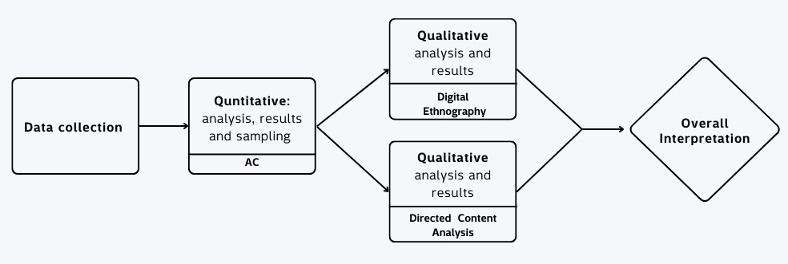
In this specific case, we chose to select only the information visible on the experience page: title, textual description, and multimedia material (photos and videos).

Figure 1: Ad-hoc exemplification of the Mixed Methods follow-up model (Cresswell & Plano Clark, 2011)
The choice of displaying only the page to define the digital environment of the experiences was made to avoid having a disabling physical presence for both the subjects observed and the observer (Kaur-Gill & Dutta, 2017). Thus, it was possible to produce a field diary that, in addition to the work of analyzing the elements, also included the handling of different forms to capture and record audiovisual information native to the digital world (Ardévol & Gómez-Cruz, 2014).
Concurrently, what according to Shannon (2005) is identifiable as a directed content analysis was produced, with the intention of investigating the elements perceived by users (the column profiles), thus attempting to deepen the results and overcome the limitations of CA. Therefore, a direct approach was initially used with the help of both categories identified by Del Chiappa and Kevin Kam Fung (2020) and new categories emerged inductively (Miles, 1994). This reasoning led to the analysis using 12 categories: Digital position, Experience Benefits, Authenticity, Enjoyment, Recommendation, Interaction with host, Initial hesitation, Sustainability, Educational, Inspiration, and Price value. The final outcome was the development of weighted concept maps focusing on the distribution of attributes based on the different geographical areas from which the users come.
The construction of the initial dataset took place by selecting 24 digital experiences on the Airbnb portal including all reviews published in the time span from the beginning of the Covid-19 pandemic (March 2020) to the end of the 'first wave' (January 2021). Subsequently, 16 digital experiences were selected for qualitative analysis based on the quality of the projection of the profiles.

Fruitors and digital experience: a multidimensional quantitative exploration.
The objective of the CA is to understand, through it, the latent structure of association between the two variables taken into consideration, to indicate the presence of similarity or dissimilarity between the column and row profiles. In other words, through the aid of this technique, we try to understand whether there are geographical areas that attend digital experiences similarly, but also go to understand how the digital experiences are dissimilar or similar to each other, as will be seen, in these elements of similarity were deepened and broken down through qualitative analysis. From a technical point of view, the first result to be taken into consideration is Cramer's V index, which in the analysis posed stood at a value of 0.127, thus indicating a low intensity of the relationship between the two variables, but also a high distance from the situation of a mutual relationship between the categories, i.e. the situation in which a place was attended exclusively by users from a single geographical macro area, a dynamic that makes the aid of the CA even more necessary. It is also worth emphasizing a p-value extremely close to 0 (precisely 9.801-272).
Another important fact is the percentage of inertia that the axes taken into consideration represent out of the total. Specifically, the cumulative percentage of inertia that the first two axes carry is 60 %, which means that the deviation from independence is well summarised by the first two axes (given that the number of modes of the variables taken into consideration is quite high). Continuing in this direction, we present the specific values of this analysis, 𝑐𝑜𝑠2, the contributions, and the reference graph.

It is good to remember that, when faced with many modes, the quality of the representation (𝑐𝑜𝑠2), is interpreted starting from a few points that are well represented, with opposite coordinates, far from the origin of the dimensions and with high values of the contributions (Husson 2017); consequently, the first two row profiles considered were, Rome and NewZeland, both are well represented on the second factor (𝑐𝑜𝑠2 respectively 0.786 and 0.3867) and with high contribution values (32.7 and 9.82 respectively). About the column profiles, the interpretation instead started from the opposition Midwest USA and East Asia (𝑐𝑜𝑠2respectively 0.4395 and 0.9308) and adequate contributions (65.24 and 3.58 respectively), continuing with this logic until all interpretable points were exhausted. In this perspective, however, it must be considered that all points with a 𝑐𝑜𝑠2minor than 0.2 were excluded from the graph taken into consideration because they suffered a strong distortion in the projection process.
The last step in the quantitative analysis is the interpretation of the resulting graph (Figure 2). Before dealing with the results, it is necessary to emphasize that the distinction between cities followed by a number, as far as the row profiles (shown in blue) are concerned, is inherent to the different experiences, this statement indicates the presence of several experiences, offered by the platform, in the same city.
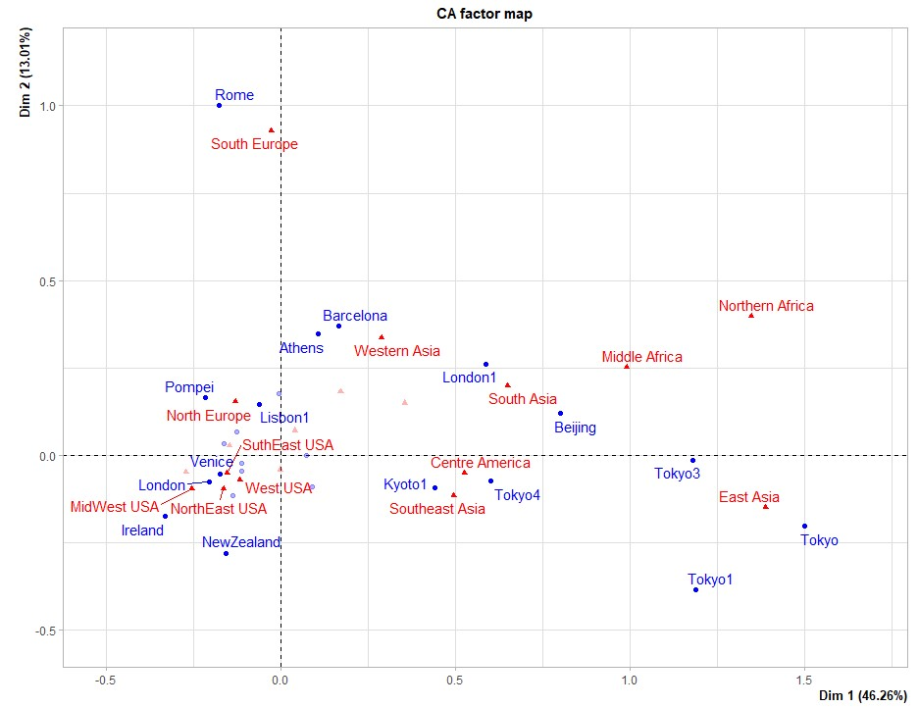
The latter shows a similar distance from the average profile of the row profiles Tokyo, Tokyo1, and Tokyo3, to these is added Tokyo4 which, on the other hand, seems to be similarly distanced from Kyoto1. This distinction allows us to understand that these experiences are enjoyed by individuals coming from the same geographic macro-areas but with some differences between them, which we recall will be explored in more detail later in the elaboration.

Figure 2 Analysis of correspondences between geographic macro-areas of residence of users and physical location of experiences.
Again in the context of the riga profiles, as noted above, we have instead an opposite way of distancing from the average profile about the Rome Riga profiles and the New Zeland and Ireland duo, although the latter distance itself more from the average profile expressed by the second factor. In other words, this positioning indicates the presence of different backgrounds between the users of the experience located in Rome and that located in New Zealand.
As far as the column profiles are concerned, on the other hand, there is a similar distance from the average profile of the first factor between the Western countries on the left and the less Westernized countries on the right, determining, in this case, an orientation towards different experiences on the part of the residents in the west and the rest.
On the other hand, as regards the intersection between the row and column profiles, the graph allows us to understand the latent structure, an example of this is the Western Asia column point which is at the same distance from the average profile represented by the first factor as the Barcelona and Athens row points, indicating to us (after checking the contributions and the quality of the projection) the distinction in making these experiences concerning the other macro-areas, that is, that this two specific experience have strong participation from residents in Western Asia, despite being located at the antipodes in Europe.

Airbnb's digital experience and perceptions of the digital space.
To explore in detail the findings from the CA, two concurrent qualitative focuses were placed, the first one pertains to digital ethnography and aims to investigate the elements of similarity and dissimilarity between the 16 digital experiences through the production of a field diary.
The observation of the digital space of AirBnB's digital experiences reveals cases that have common characteristics among them such as the three experiences located in the capital of Japan (Tokyo, Tokyo1, and Tokyo3). These present similarities not only in the structuring of the pages, having the same explanatory architecture (absence of trailers, images identifying the host and the elements to be observed), but also in the cultural values they display, defining a narrative of the city based mainly on cultural traditions and the places that represent them. Already from this, it is possible to determine a certain marriage between digital and real space, which is fused into a single hybrid environment.
Another set of experiences that were analyzed derived from the popular culture of the web is the sphere of cultural products about the world of literature, Japanese audiovisual products, and the world of video games, which can be found in the experiences located in London (London) and Tokyo (Tokyo4).
The particularity of these cases is immersive that is placed at the center of the experience page, thus resulting in an experience created specifically for fans of a certain niche. The images produced, e.g. the photo of the London station, emphasize elements of the series to which they pertain; in the case of London, which is centered on Harry Potter, there is no lack of quotations in each element, to strongly emphasize the passion for a particular content.
Then some experiences define a transposition of the classic tour that each city has in a digital perspective. Four experiences emerge, Rome, Venice, Pompeii, and Barcelona. They have common elements in both page structure and multimedia elements. They all present clear and concise descriptions of the activities to be performed during the tour, with very explanatory images and trailers. The thematic focus of the tours varies according to the characteristics of the cities and their consequent traditions, so the narrative they adopt changes according to the type of tour one wishes to set up. It should also be emphasized that the three Italian experiences have a more classical structure, since all three hosts are certified tourist guides from their region, and the structure of the page is based precisely on this element.
A final result inherent to digital ethnography concerns those experiences that define the structure of pages and the resulting narratives exclusively on the explanatory power of the images they are composed of. These experiences (Athene and Lisbon1) focus their theme on the power of images, totally distancing themselves from the other experiences. Here, the driving element is the graphic impact that the trailer and images convey, defining a purely stylistic narrative, and trying to unite physical space, digital space, and graphic rendering.
To understand which elements are most perceived within a digital experience and how the perception of these elements varies according to the area of residence, a directed content analysis was carried out, manually examining the reviews present online on the 16 digital experiences investigated.
The categories generated to best synthesize the data were created through a review of the reference literature and based on the interpretation of the researcher during the analysis of the reviews, as mentioned above, 11 categories were identified which were verified through the Krippendorff coefficient on a portion of the dataset which was found to be 0.73, consequently acceptable to implement the entire coding of the dataset.
The coding structure of the variables that were integrated into the dataset is as follows:
- Digital position, this category was created to describe possibilities for replacing physical experiences with digital experiences.
● Experience benefit, this category refers to the set of multimedia content that hosts offer during their experiences and which can influence user satisfaction.
● Authenticity, with this category we refer to the user's feeling of implementing a 'real' journey during the digital experience, i.e. feeling physically transported to the place through the interaction with the host. (Li, 2022)
● Enjoyment, This category was constructed to emphasize mainly new types of communication modes outside the classic accounts of the local reality that are implemented by the host during the experience.
● Recommendation, this category refers to a recommendation suggested by a user who has already lived the digital experience in person, open to interested potential users, or who in turn has been recommended by other users.
● Interaction with host, the host plays a fundamental role in experiences on Airbnb, several studies show that good communication with the host is one of the crucial aspects associated with guest satisfaction (Baute-Diaz, 2019), consequently this category was posed with the desire to understand if it was present in the reviews, regarding digital experiences on Airbnb, the same importance indicated by previous studies in offline experiences.
● Initial hesitation is defined as the perceived uncertainty regarding the possible negative consequences of purchasing a product or service (Featherman, 2003). In one study it was stated that initial hesitation is insignificant in the purchase choice on Airbnb (Gong & Zheng, 2018)other studies have identified the negative effect of hesitation on attitude on purchase intention (Liang, 2015) consequently we aim to understand whether this hesitation was present in the purchase and enjoyment of the digital experience.
● Sustainability, this category was constructed based on the guest's possible perception of a sustainable experience. Airbnb offers an offline experience called "glamping" in Western North Carolina, this experience is described as "a luxury camping destination in the Blue Ridge mountains of North Carolina" (Airbnb, 2017), therefore the presence of this category is geared towards understanding whether through the internet the sustainability of an experience was perceived by users.

● Educational, an educational experience is seen as the acquisition of new knowledge, skills, or techniques by the experience in question, in the tourism literature, a key motivating factor for travel is the desire for self-education (Prentice, Witt, & Hamer, 1998) consequently, the definition of this category makes it clear that there is a desire to understand whether the same motivational drive identified by Prentice is present in the purchase of digital experiences.
● Inspiration, modern technology has facilitated the creation of a connected world in which virtual travel, promotes new opportunities for distance learning not only limited to the acquisition of new knowledge and skills but primarily promotes cultural exchanges, understanding, and new inspirations for tourists (Chen, 2017), this attribute was constructed to understand whether this conception of learning as a possibility for personal innovation is present in the purchase of digital experiences.
● Price value, is defined to understand whether the user in choosing an online experience considers the price of the experience and whether it is worth the purchase (Luo, 2019).

Figure 3: Representation of the perceived intensity of the attributes Digital Position, Experience Benefits, Authenticity, Inspirational.

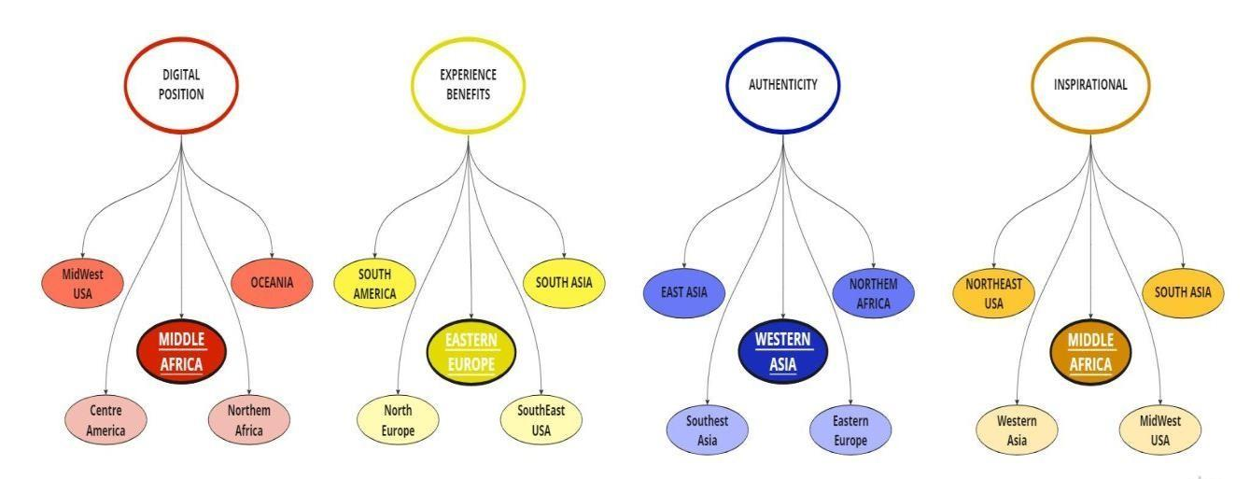
For the digital position category, the countries that perceived this attribute the most were those belonging to Central Africa while the countries that perceived it the least were those belonging to Central America. Central Africa in January 2022 appears to have achieved a very good degree of digitization as the internet is present in most of the countries in this geographical area (Kamer, 2022). The living conditions in Central Africa remain dire due to poor living conditions, and lack of food and water (Situation Reports, 2021) it can be deduced that the online experience is a kind of escape from the reality in which the citizens of those areas find themselves living every day. Central America is a region with deeply rooted ancestral traditions and includes festivals that combine indigenous and Spanish influences, religiosity plays an important role within communities and revolves around saints, who are perceived as intercessors between human beings and God ( (Celebrations in Central America, indigenous traditions and Spanish culture., 2019) consequently it can be deduced that despite the digitization that has taken place in Central America, tradition has a greater impact on citizens and therefore any digital experience does not replace the experience in the real world.
Regarding the category Experience Benefits the geographic area that perceives this attribute the most is Eastern Europe i.e. countries such as Poland, Bulgaria, and Hungary, etc. 2022 digital culture has strongly penetrated within these areas with access to various multimedia content that until a few years ago did not circulate (Kemp, 2022)consequently it can be assumed that the presence of a multitude of multimedia content within their culture leads them to want to receive the same services during digital experiences. The geographical area that perceives the least from this attribute is the SouthEast USA an area where the countries within this area are politically conservative (Most Conservative States in America, 2022)it is theorized that in the search for digital experiences, people seek more of a traditional way of telling their cultures.

The geographical area that perceives this attribute the most is West Asia, Iraq, Israel, Syria, etc., countries where human rights are very often violated and the quality of life is catastrophic ((Worth Report 2022: Palestine and Israel, 2022, World Report 2022: Iraq, 2022). The area that least perceives the attribute turns out to be South East Asia. The latter is known in the international world for its attachment to its traditions of origin, consequently, it is assumed that the choice of digital experiences is connected more to an educational sphere, i.e. the search for new knowledge.
Regarding the category Inspiration, the geographical area that perceives it the most is Central Africa, as explained in the digital position category this is related to real-life conditions, consequently a journey also through digital becomes a source of personal growth and confidence in a possible better living condition. (West and Central Africa| Situation Reports, 2021)The geographical area that least perceives this attribute is the MidWest USA where the quality of life is excellent and stress-free (Young, 2018), consequently there is no need to seek inspiration for personal growth.
The Recommendation category mainly indicates the presence in the analyzed reviews of referrals on an experience implemented to better direct other users, the geographic area that most perceives this attribute is West Asia, it is thought that this is probably due to the poor economic condition within those countries ( (Roth, 2022) (World Report 2022: Western Asia, n.d.)consequently people prefer to implement digital experiences recommended by others to be sure that it is of value both economically and culturally. The geographic area least influenced by this category is the MidWest USA, as reported in Olivia Young's article the living conditions in these areas are highly affluent (2018), consequently it is assumed that people in those areas do not give weight to online reviews when choosing which digital experiences to implement.
The category Hesitation is most perceived in the SouthWest USA, strongly conservative countries that are very attached to traditions, it is assumed that the most congruent motivation for this hesitation in implementing digital experiences can be traced back to the cultural condition of these states.
The states that perceive this attribute the least are those in the West USA that are strongly digitized, in the report on the digital condition it is indicated how the virtual world is used in every aspect of their daily lives, consequently, it can be assumed that there is less hesitation in the use of digital experiences due to the constant use of the virtual by the citizens of those areas (Technology and Equity in Cities., 2019)
The category Interaction with host indicates the social interaction during a digital experience, the area most affected by this attribute is the SouthWest USA which can be attributed to the conservative political condition of those countries (Most Conservative States in America, 2022), consequently, it is assumed that this greater interest in interaction with the host is generated by the need, of people to have constant contact during the entire experience with the host. The area that has least perceived this attribute is the West USA which is heavily digitized, it is assumed that users in those territories being accustomed to digital do not need constant reassurance from a physical person. (Technology and Equity in Cities, 2019).
Sustainability mainly concerns the search for virtual experiences perceived as sustainable by the users, this attribute is strongly perceived by the countries of Southeast Asia probably due to the poor conditions of pollution both due to the excessive presence of plastic and the constant rise in sea levels (The Sustainability Gap in Southeast Asia., 2022), it is hypothesized that the selection of sustainable experiences is to be attributed to the absence of sustainability in everyday reality. The area that perceives this category the least is Northwest Asia, which is ranked as the most sustainable country in Asia (Lu & al, 2021), it is hypothesized that people who are accustomed to sustainability in their everyday reality are looking for different things in digital reality.
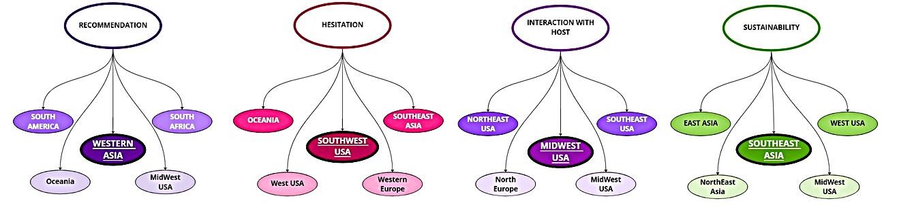
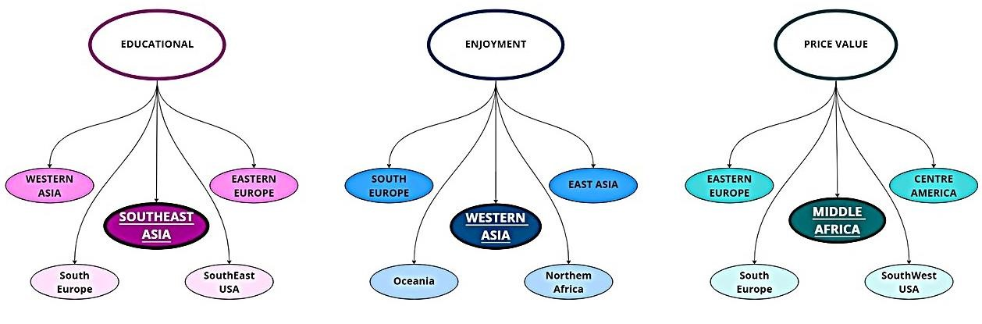
The educational category is perceived more in South East Asia, which is an area strongly controlled by the Islamic religion (Kahn & Rabasa, 2005) consequently, it is assumed that the constant search for new forms of knowledge is through the search for digital educational experiences. The area that perceives this attribute the least is South Europe, an area in which poor education has been identified, i.e. the level of education in these countries is lower than in other European areas (Åslund, 2013), through a reading of user reviews from these areas it is identified that the selection of digital experiences takes place for the search of common interests with hosts and for enjoyment.

Figure 4 Representation of the perceived intensity of the attributes Recommendation, Hesitation, Interaction with Host, Sustainability.

Figure 5 Representation of the perceived intensity of the attributes Educational, Enjoyment, Price Value.
The enjoyment category is mainly perceived in the West Asian area as reported in the 2022 report the living conditions in this area are difficult (Roth, 2022), it is hypothesized that people within these areas search for what is missing within their everyday reality which is characterized by war and famine. The area that is least affected by this attribute is Oceania, people in these areas are ranked as the happiest in the world (How outstanding is life in Oceania?, 2017), it can be inferred that people usually search in the digital world for what is not present in their everyday reality, Oceania is among those areas that search most for an educational experience.
The last category of price value may prove to be the most intuitive to analyze and justify, the geographical area most influenced by this attribute turns out to be Central Africa which as reported in the report is characterized by a disastrous economic situation (West and Central Africa| Situation Reports, 2021) it can be theorized that the lack of economic possibilities decides to select an experience more meticulous due to the lack of economic possibilities in those areas. The area that least perceives this attribute is the SouthWest USA, with a particularly affluent economy based on oil and oil (Cañas, 2020) it is assumed that the condition of the population is particularly affluent consequently the price of a digital experience is not one of the most considered factors.

Conclusions

To present the joint product of all the analyses proposed thus far, it is useful to consider first of all Cramer's coefficient V, which stands at 0.127, indicating a low intensity of the relationship between the place of residence of the users and the physical location of the experience enjoyed, which allows us to corroborate the absence of a strong dependence between the two variables taken into consideration. In other words, this value shows us that the choice of the experience depends to a limited extent on the place where it physically takes place. This dynamic is strongly corroborated by the results produced by digital ethnography which denotes that the elements characterizing the structure of digital experience pages are the theme, which is not a simple feature supporting the experience. The chosen thematicization becomes the driving element in the constitution of the identity of the digital experience, which is formalized on the page. The city becomes a supporting element, allowing the theme to be enhanced. Spatiality, however, is not excluded but emphasized in another dimension, namely the possibility of being able to digitally travel the city. In support of this, from the results of the Content Analysis, it is possible, taking into consideration the attribute digital position, to deduce that in the case of Central Africa where the difficulty of living and conversely of traveling, leads to a greater demand for the perception of physical space. In other words, it is possible to argue that the concept of spatiality, in this type of relationship, does not have a preponderant weight. Choices are no longer made based on place, but based on the technical structuring of the page and the themes of reference, leading to an exponential increase in such dynamics in countries with difficult living conditions.
On the other hand, taking into consideration the graphic output resulting from the correspondence analysis, as pointed out before, an opposition between Westernized and less Westernized countries is determined, however, the results of the content analysis place within the field elements that cannot be taken into consideration through the simple aid of the CA. These include elements about attachment to traditions, economic well-being, respect for environmental issues from a sustainability perspective, and hesitation to participate in digitally enjoyed experiences.

The use of a Mixed Methods approach is fundamental to understanding these elements, given that through the CA it is possible to understand the latent structure underlying a phenomenon but not to understand the compositional elements of the same; and it is precisely in pursuit of these aims that the content analysis was carried out, which allowed us to observe the conformation of the same latent structure.
Lastly, to make the integrations of the analyses posed thus far more comprehensible, it seems useful to dwell on a specific case, namely the Rome experience and the South Europe macro area. It can be seen from the output of the CA, given also the absolute and relative contributions, that the Rome experience is more frequented by the South Europe Macroarea. This, from a logically inductive point of view, seems to be a counterintuitive behavior, given that in any case the two areas are physically "overlapping". However, by investigating in depth, through qualitative techniques, it was possible to understand the motivations behind this behavior. As can be deduced from the results presented above, the geographical macro-category South Europe is not very accustomed to perceiving, and consequently to enjoying, experiences with a high educational level (remember that poor education has been identified in this area). Convexly, this is justified by the results of the digital ethnography, which indicate, precisely, that for this specific experience, there are no elements in either structure or content that aim to place an educational dimension at the center of the experience, concentrating instead on the recreational one, as the content analysis reflects. These dynamics are not exclusively framed by elements of similarity since several elements appeared in the analysis that instead shows instances of dissimilarity. For example, the geographic macro-area category Southeast Asia and the experience of Pompeii are polarised within the output resulting from the CA, in fact following a logical reasoning like the previous one, through this process of analysis, it is possible to understand how Southeast Asia is mainly related to the themes of education.
(as value enhancement) and sustainability, which is in total contrast to the Pompeii experience, which places the digital transposition of a guided tour of the archaeological excavations in the structure of the page.
In conclusion, this type of analysis is identifiable as a process that aims to understand how the users of digital experiences and the digital experiences themselves are in their integration a complex phenomenon that must be analyzed obligatorily from several points of view and consequently requires the obligatory aid of a Mixed Methods approach.

Bibliografy

-Ardévol, E., & Gómez-Cruz, E., (ed.) Digital ethnography and media practices. In E. &.-C. Ardévol, The international encyclopedia of media studies,. Wiley-Blackwell 2014.
-Åslund, A., Southern Europe's Problem: Poor Education. PIIE. Peterson Institute for International Economics 2013.
-Baute-Diaz, N., Gutiérrez-Taño, D., Díaz-Armas, R.. Interaction and reputation in Airbnb: an exploratory analysis. International Journal of Culture, Tourism and Hospitality, 2019, 13.
-Bizzarri, C., L’impatto di nuovi flussi turistici a scala globale: il caso della community delle golf, in ” Bollettino della società geografica italiana, Roma, 2013, Serie XIII, vol. VI, pp. 471-487
-Cañas, J.. Southwest Economy. Federal Reserve Bank of Dallas 2020.
-Cenni, I., & Vasquez, C., Early adopters’ responses to a virtual tourism product: Airbnb’s online experiences. International Journal of Culture, Tourism and Hospitality, 2021, Research, 16, Issue 1.
-Chen, L. S. Mindful tourist experiences: a Buddhist perspective. Annals of Tourism Research, 2017, 64.
-Cheng, M. & Jin, X. What do Airbnb users care about? An analysis of online review comments, International Journal of Hospitality Management , 2019, 76.
-Conservative Move, Most Conserative States in America 2022.
- Creswell J. W. & Plano Clark V. L., Designing and conducting mixed methods research (2nd ed.). SAGE Publications 2011.
- Chiappa, G., Sini, L., & Atzeni, M., A motivation-based segmentation of Italian Airbnb users: An exploratory mixed approach. European Journal of Tourism Research, 2020, 25, 2505.
-Dolnicar, S., & Talebi, H., Does hosting on Airbnb offer hosts vacation-like benefits? Proposing a reconceptualization of peer-to-peer accommodation. Journal of Hospitality and Tourism Management, 2020, 43.
-Featherman, M., Predicting e-services adoption: a perceived risk facets perspective. International journal of human-computer studies, 2003, 59(Issue 4).
-FinGlobal, How outstanding is life in Oceania? 2017
-Gherghi, M., & Lauro, C., Appunti di Analisi dei Dati Multidimensionali. Napoli: RCE Multimedia 2010.
-Gong, J., & Zheng, Y., A study on the motivation and constrain factors influence Chinese travelers’ attitude towards Airbnb. DiVa| Digitala Vetenskapliga Arkivet 2018.
-Gunning, P., What Are Airbnb Experiences and Can They Increase Your ROI? 2020
-Guttentag, D., Virtual reality: Applications and implications for tourism. Tourism management, 2010, 31, Issue5.
-Guttentag, D., Progress on Airbnb: a literature review. Journal of Hospitality and Tourism Technology, 2019, 10, Issue
- Hesse-Biber, S., Qualitative Approaches to Mixed Methods Practice. Qualitative Inquiry, 2010,16(6), 455-468.
- Hine, C., Cyberscience and Social Boundaries: The Implications of Laboratory Talk on the Internet. Sociological Research Online, 2002, 7(2), 80-95.
-Human Rights Watch, Worth Report 2022: Palestine and Israel, 2022, World Report 2022: Iraq.
-Human Rights Watch, World Report 2022: Western Asia 2022.
-Inte Coleman, E., Ethnographic Approaches to Digital Media. Annual Review of Anthropology, 2010, 39.
-Kahn, H., & Rabasa, A., Islamic Education in Southeast Asia. Hudson Institute 2005.
-Kamer, L., Africa: internet penetration by country, Statista 2022.
-Kaur-Gill, S., & Dutta, M., Digital Ethnography. Singapore: National University of Singapore 2017.
-Kemp, S., Eastern Europe- State of Digital. DataReportal 2022.
-Kevin Kam Fung, S. (n.d.). Motivations and constraints of Airbnb consumers: Findings from a mixed-methods approach. Tourism Management.
-Krippendorff, K., The Content Analysis Reader. SAGE 2009.
-Lessing, L., Remix: Making Art and Commerce Thrive in the Hybrid Economy. New York: Penguin 2008.
- Li, J., So, K. K. F., & Hudson, S., Customer responses to the Airbnb platform: the role of Airbnb experience and memorability: the role of Airbnb experience and memorability. International Journal of Contemporary Hospitality Management, 2022, 35(3), 1068-1086.
- Liang, L., Choi, H.S., Joppe, M., Understanding repurchase intention of Airbnb consumers: perceived authenticity, electronic word-of-mouth, and price sensitivity. Journal of Travel & Tourism Marketing, 2017, 35. 1-17.
- Liang, Lena & Choi, Hwansuk & Joppe, Marion, Exploring the relationship between satisfaction, trust and switching intention, repurchase intention in the context of Airbnb. International Journal of Hospitality Management, 2018, 69. 41-48.
-Lu, M., Which Asian Economies Have the Most Sustainable Trade Policies? Visualcapitalist, 2021
-Luo, Y., Understanding hidden dimensions in textual reviews on Airbnb: an application of modified latent aspect rating analysis (Lara). International Journal of Hospitality Management, 2019, 80.
- Marine-Roig E. Measuring Online Destination Image, Satisfaction, and Loyalty: Evidence from Barcelona Districts. Tourism and Hospitality. 2021, 2(1):62-78
-Norum, R., & Polson, E., Placemaking ‘experiences’ during Covid-19. Sage journals, 2021, 27, Issue 3
-OOI N. e J.H. LAING, Backpacker Tourism: Sustainable and Purposeful? Investigating the Overlap between Backpacker Tourism and Volunteer Tourism Motivations, in «Journal of Sustainable Tourism», 2010, 18, 2, pp. 191-206.
-Pine & Gilmore, J. H., The Experience Economy., Harvard Business School Press 1999.
- Prentice, R., Witt, S.F., & Hamer, C., Tourism as experience: The case of heritage parks. Annals of Tourism Research, 1998, 25, 1-24.
-Roth, K. (2022). World report 2022: Israel and Palestine. uman Rights Watch 2022.
- Hsieh H-F, Shannon SE., Three Approaches to Qualitative Content Analysis. Qualitative Health Research. 2005, 15(9), 1277-1288.
-Situation Reports, West and Central Africa| Situation Reports 2021.
- Sthapit, E. & Jiménez Barreto, J., You never know what you will get in an Airbnb: Poor communication destroys value for guests. Current Issues in Tourism. 2018, 22.
- Tussyadiah, I., Factors of Satisfaction and Intention to Use Peer-to-Peer Accommodation. International Journal of Hospitality Management, 2016, 55, 70–80.
-Urban Institute, Technology and Equity in Cities 2019.
-Visit Centroamérica, Celebrations in Central America, indigenous traditions and Spanish culture 2019.
- Wong, I.A., Lu, M.V., Lin, S., & Lin, Z., The transformative virtual experience paradigm: the case of Airbnb’s online experience. International Journal of Contemporary Hospitality Management 2022.
-Woodward, M., Airbnb Statistics: User & Market Growth Data 2022.
-Young, O., How the MidWest id different. BusinessInsider 2018.
- Zheng-ying, L., Study Review about Foreign Network Virtual Tourism:Retrospect and Prospect. Tourism Tribune 2009.
- Zhu, J., & Cheng, M., The rise of a new form of virtual tour: Airbnb peer-to-peer online experience. Current Issues in Tourism, 2021, 25, 3565 - 3570.

Harvard 2015, Airbnb and The Sharing Economy: Creating Value for Everyone, Technology and Operation Management;
Spatiality understood as physical space.
Sprague and Zimmerman (2004) noted, “When we encounter apparently different findings from each method, we need not immediately assume that one should be refuted and the other accepted” (p. 53).
With the desire to better understand the interaction between the variable's modes and to better represent the plan resulting from this technique, a recoding by macroareas was implemented subject to the principles of distributional equivalence that this technique enjoys (Gherghi and Lauro, 2010).
With the desire to better understand the interaction between the variable's modes and to better represent the plan resulting from this technique, a recoding by macroareas was implemented subject to the principles of distributional equivalence that this technique enjoys (Gherghi and Lauro, 2010).
Reliability was tested on a portion of the dataset using Krippendorff's alpha (2009).
Concept maps were produced through the use of Miro software.
The sampling process was exclusively implemented on digital experiences and not on geographic macroareas, this choice is attributable to the desire not to lose a large amount of information on geographic macrocategories, while also trying to go beyond another limitation of the CA. In addition, only modes with an 𝑐𝑜𝑠2with a value greater than 0.2 were considered because points with an 𝑐𝑜𝑠2 lower than the limit value we referred to are uninterpretable (Husson 2017).
It is emphasized that the sampling process described so far was exclusively implemented on digital experiences and not on geographic macroareas. This choice is attributable to the desire not to lose a large amount of information on geographic macroareas, while also trying to go beyond another limitation of the CA.
The AC (Gherghi and Lauro, 2010) refers to the variable "Place" (physical location of the experience) and the variable "Residence" (place of residence of the user of the digital experience, coded by geographic macro-areas), which, as usual, are placed within a contingency table before being analyzed. The Place variable was placed in the row while the "Residence" variable.
The proportion system (exemplified), which underlies this information is the ratio of the number of experiences made by individuals from this macro area, proportioned to the number of total experiences produced in Barcelona and Athenes.
The minimum acceptable value when referring to this coefficient is 0.67.

