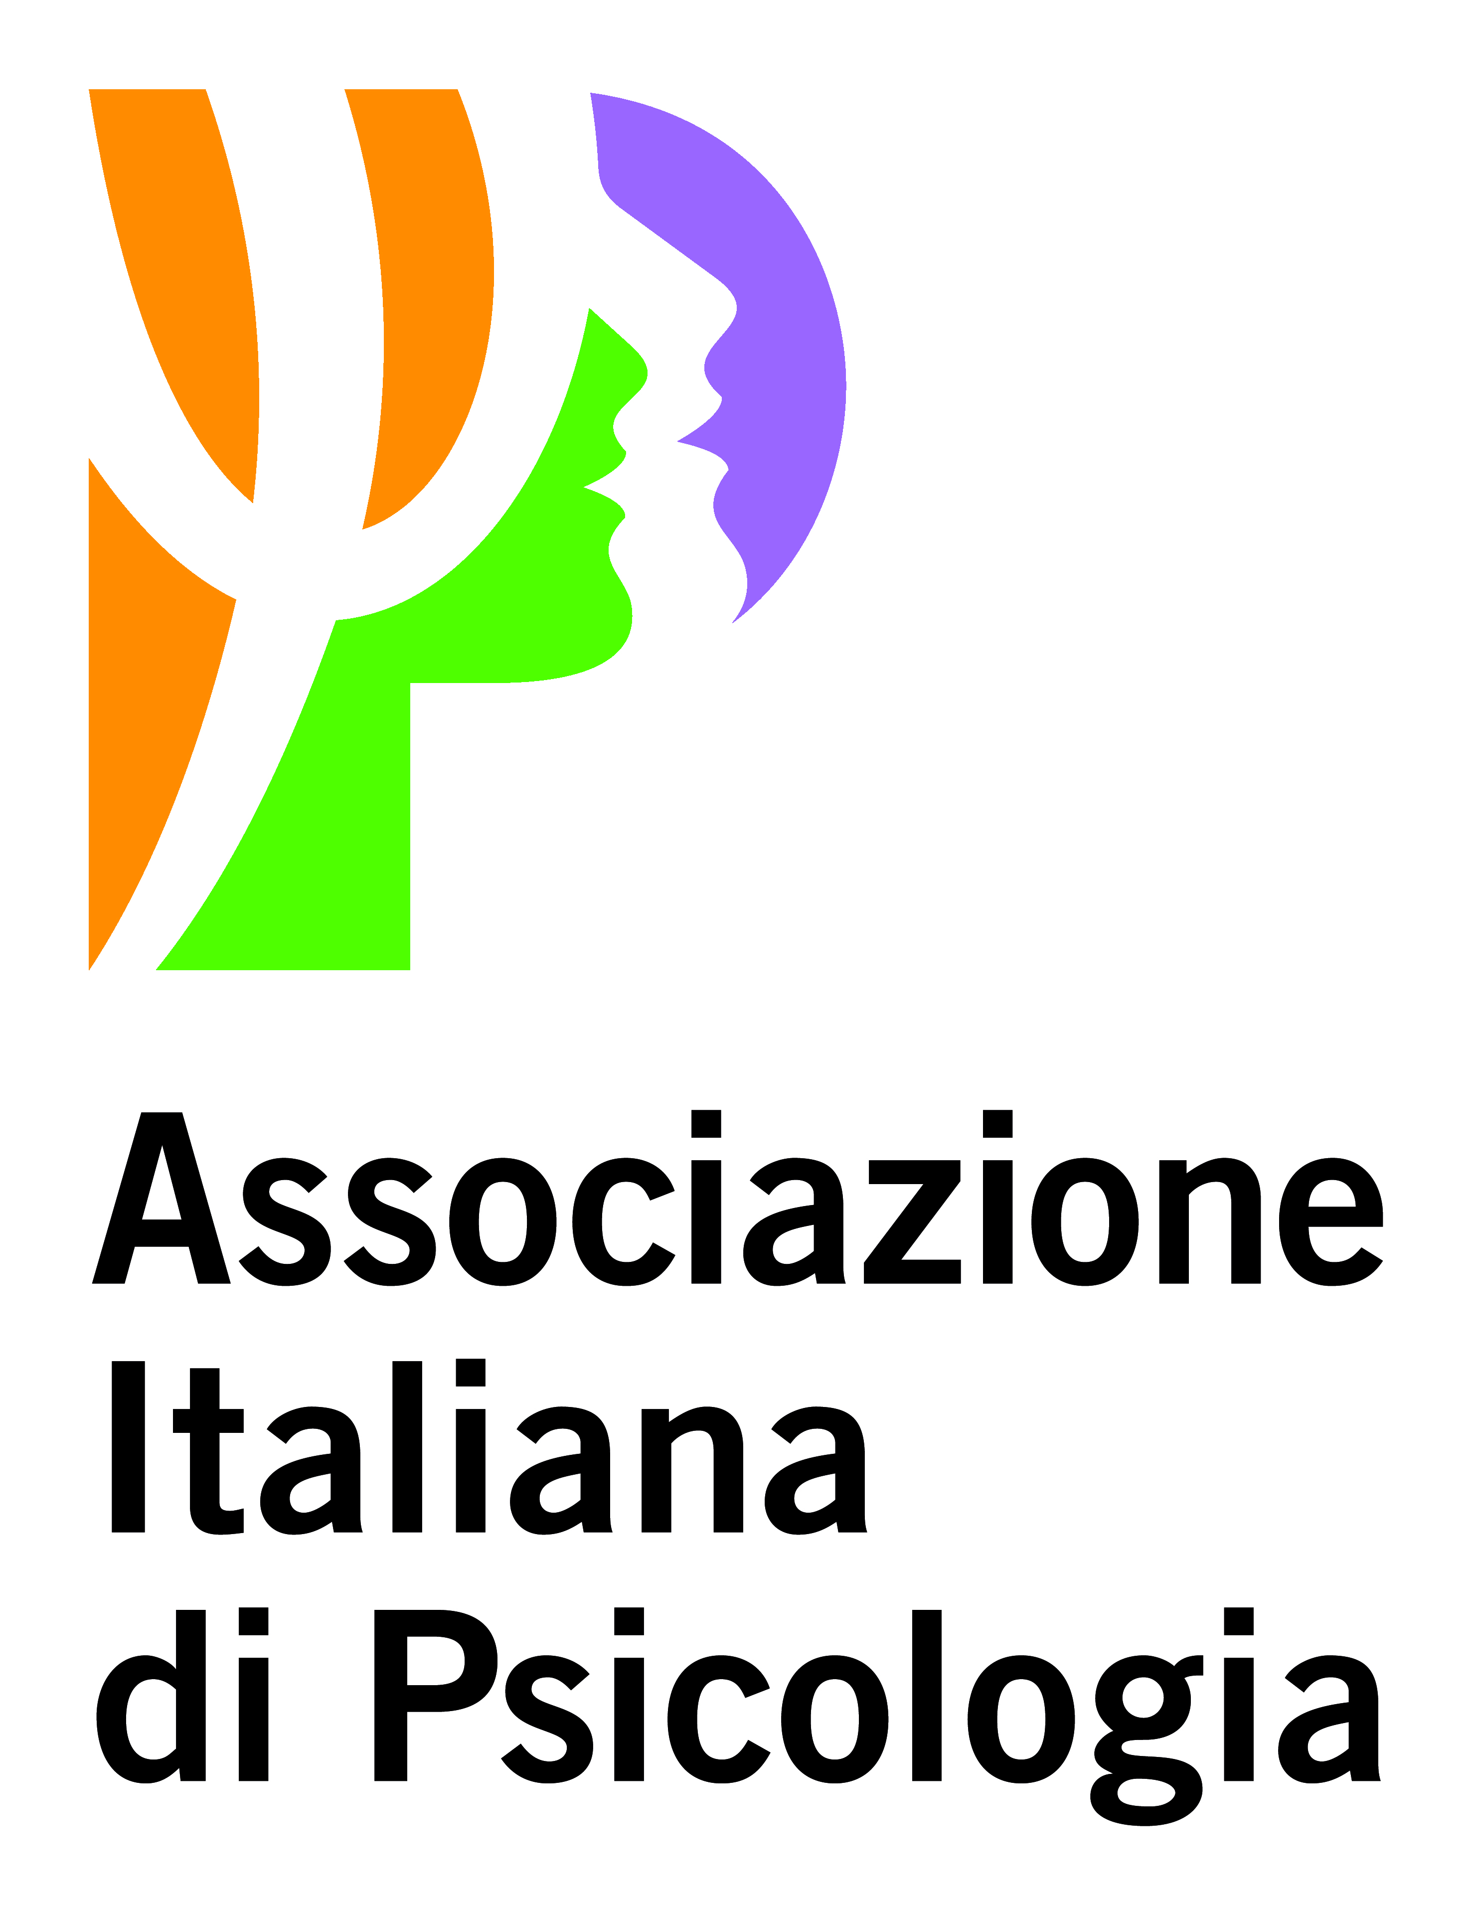
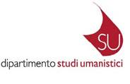
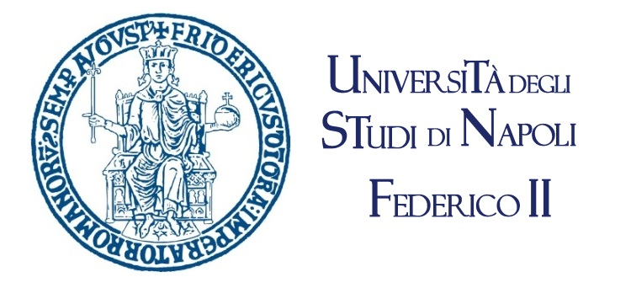

In occasion of the 8th Volume of Yearbook of Idiographic Science

Conference

IDIOGRAPHIC APPROACH TO HEALTH



October 27th - 28th - 29th, 2016

Department of Humanistic Studies
University of Naples Federico II

October 27th Thursday
Aula Iacono

- h. 15.00 WELCOME
- Prof. Arturo De Vivo, Prorector of University of Naples Federico II (Italy)
- Prof. Edoardo Massimilla, Head of Department of Humanistic Studies, University of Naples Federico II (Italy)
- Prof. Francesco Palumbo, Coordinator of Degree Courses in Psychology, Department of Humanistic Studies, University of Naples Federico II (Italy)

- h. 15.20 INTRODUCTION
- Sergio Salvatore (University of Salento, Italy)
- Maria Francesca Freda (University of Naples Federico II, Italy)

- h. 16.30 COFFEE BREAK

- h. 16.45 ARENA DISCUSSION: HEALTH & ILLNESS
Discussants: Yair Neuman (Ben-Gurion University of the Negev, Israel) & Tatsuya Sato (Ritsumeikan University, Japan)

- Lívia Mathias Simão (University of São Paulo, Brazil) & Giuseppina Marsico (University of Salerno, Italy; Aalborg University, Denmark) Disquieting Experiences, Borders and Healthcare processes
- Sven Hroar Klempe (Norwegian University of Science and Technology, Norway) Four contradictory expressions in scientific discourse
- Robert E. Innis (University of Massachusetts Lowell, USA and Aalborg University, Denmark) The Enigmatic Soul of Health
- Emanuela Saita, Sara Molgora & Chiara Acquati (University Cattolica del Sacro Cuore, Italy) The idiographic science perspective applied to the treatment of younger women with BRCA mutation

October 28th Friday
Aula Iacono
- h. 9.30 CONTEMPORARY ROUTES TO IDIOGRAPHYC APPROACH
Discussant: Sergio Salvatore (University of Salento, Italy)
- Jaan Valsiner (University of Aalborg, Denmark)
- Tim Thornton (University of Central Lancashire, United Kingdom)

Open discussion

- h. 11.00 COFFEE BREAK

- h. 11.15 ARENA DISCUSSION. CLINICAL PRACTICE: CONTEXTS AND CHALLENGE
Discussants: Emanuela Saita (University Cattolica del Sacro Cuore, Italy) & Robert Innis (University of Massachusetts Lowell, USA and Aalborg University, Denmark)

- Annalisa Venezia (University of Salento, Italy) Compliance in the physician-patient relationship: a semiotic-cultural perspective
- Raffaele De Luca Picione, Francesca Dicè & Maria Francesca Freda (University of Naples Federico II, Italy) Health and disease. From reification to semiotization of their processes of signification. From medicalising discourse to situated practices.
- Tatsuya Sato (Ritsumeikan University, Japan) Self dialogue of Fukushima evacuator, to go home or not that is a question.

- h. 13.30 SOCIAL LUNCH BREAK

- h. 15.00 DISCUSSION ARENA. NARRATION AND HEALTH
Discussants: Andrea Smorti (University of Florence, Italy) & Sven Hroar Klempe (Norwegian University of Science and Technology, Norway)

- Andrea Smorti (University of Florence, Italy) & Chiara Fioretti (European Institute of Oncology) The use of narrative with oncologic patients health psychology: its implications for an idiographic approach in health research
- Yair Neuman (Ben-Gurion University of the Negev, Israel) "I Get along without You...": Billy Holiday and the Caesura of Oblivion
- Roberto Vitelli (University of Naples Federico II, Italy) Psychopatology, mental illness, and relationship between idiography and health: the case of transsexuals’ experience

- h. 17.00 COFFEE BREAK

- Maria Luisa Martino & Maria Francesca Freda (University of Naples Federico II, Italy) Narrative transformative functions for a diachronic processing flow of cancer traumatic experience: a theoretical and clinical model
- João Tiago Oliveira, Miguel M. Gonçalves, João Baptista & Adrián Montesano (University of Minho, Portugal) The power of self-narratives in health
- Daniela Lemmo & Adele Nunziante Cesàro (University of Naples Federico II, Italy) Risk and prevention. Obstacles for a cancer screening among women's experiences

October 29th Saturday h. 9.30 – 14.00
FOQUS ??

- h. 9.30 DISCUSSION ARENA: HEALTHCARE CONTEXTS AND TRANSITIONS
Discussants: Lívia Mathias Simão (University of São Paulo, Brazil) & Raffaele De Luca Picione (University of Naples Federico II, Italy)

- Santa Parrello (University of Naples Federico II, Italy) Growing Up in the Suburbs: Stories of Adolescents at Risk and of their “Maestri di Strada”
- Barbara Cordella & Susy Capasso (La Sapienza - University of Rome, Italy) A salutogenic intervention in the generational business
- Jensine Ingerslev Nedergaard (Aalborg University, Denmark) Communicative partnership between more than two: When a child becomes a patient

- h. 11.30 COFFEE BREAK

- h. 11.45 CONCLUSIONS.

- Maria Francesca Freda (University of Naples Federico II, Italy) & Sergio Salvatore (University of Salento, Italy) Perspectives on idiographic approach to health and plans for the next YIS Series’ Volume.

SCIENTIFIC COMMITTEE:
Maria Francesca Freda, Department of Humanistic Studies - University of Naples Federico II (Italy)
Raffaele De Luca Picione, Department of Humanistic Studies - University of Naples Federico II (Italy)
Giovanna Esposito, Department of Humanistic Studies - University of Naples Federico II (Italy)
Maria Luisa Martino, Department of Humanistic Studies - University of Naples Federico II (Italy)
Jensine Ingerslev Nedergaard, Niels Bohr Centre for Cultural Psychology - Aalborg University (Denmark)
Sergio Salvatore, Department of History, Society and Human Studies – University of Salento (Italy)
Jaan Valsiner, Niels Bohr Centre for Cultural Psychology - Aalborg University (Denmark)

ORGANIZING COMMITTEE:
Raffaele De Luca Picione, Department of Humanistic Studies - University of Naples Federico II (Italy)
Francesca Dicé, Department of Humanistic Studies - University of Naples Federico II (Italy)

Places of conference are:

Aula Iacono, placed in Department of Humanistic Studies at via Porta di Massa, n. 1, stairs B, 2° floor (Napoli).

Conference Language English
The partecipation in the conference is free.
Please confirm your presence
by email at raffaele.delucapicione@unina.it

